Practical No.15
Implementation of SOAP web service to convert temperature from Celsius to Fahrenheit and call web service using Java/.NET and python.

Server Side
/*
* To change this license header, choose License Headers in Project Properties.
* To change this template file, choose Tools | Templates
* and open the template in the editor.
*/
package server;

import javax.jws.WebService;
import javax.jws.WebMethod;
import javax.jws.WebParam;

/**
*
* @author Administrator
*/
@WebService(serviceName = "D2F_Jillani_6024")
public class D2F_Jillani_6024 {

/**
* Web service operation
*/
@WebMethod(operationName = "D2F")
public String D2F(@WebParam(name = "n1") double n1) {
double ans = (n1*(9.0/5.0) +32);

return "The Celsius Temperature "+n1+" in Fahrenheit is "+ans;

}
}

Output

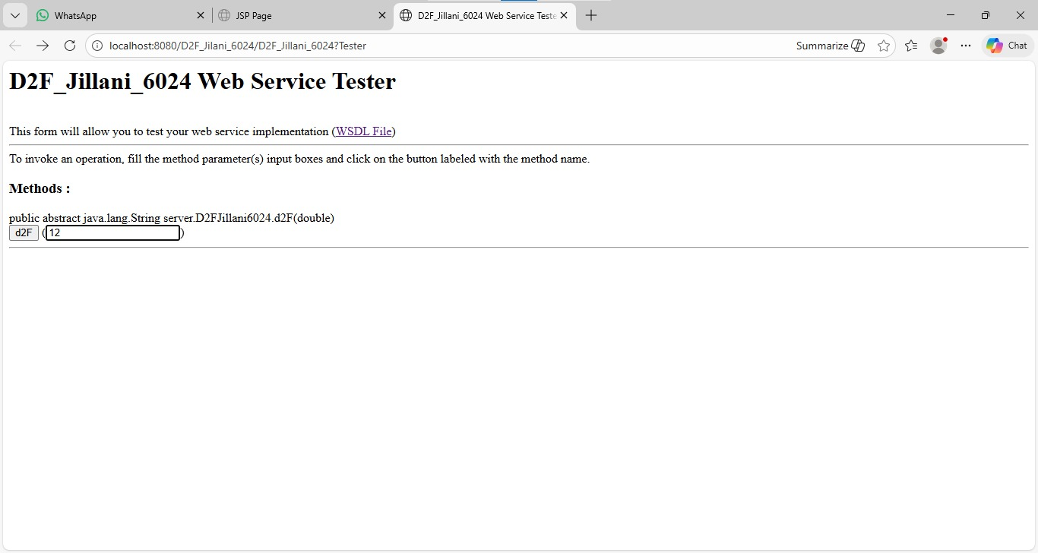

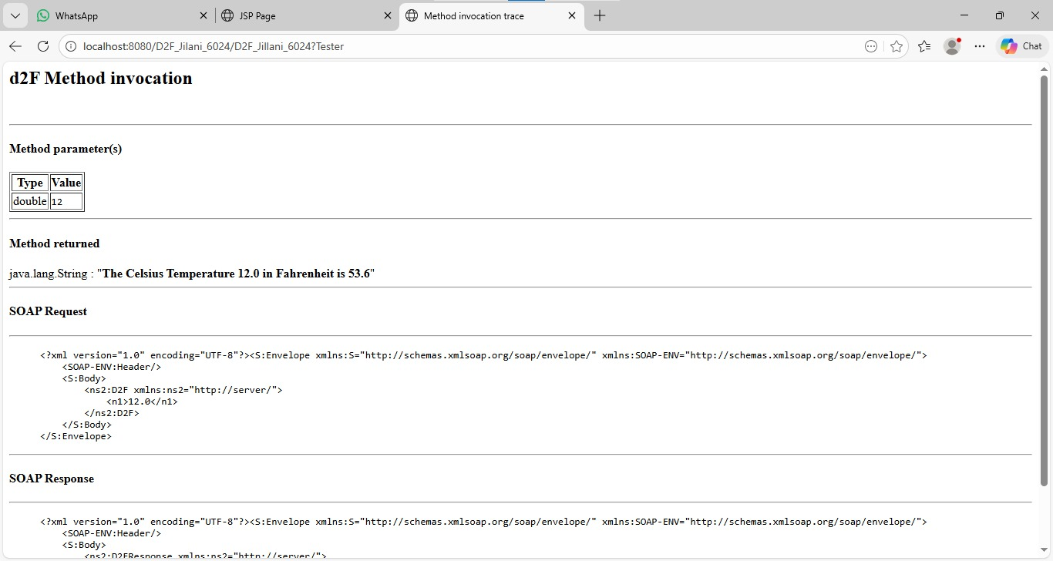

Java Client

Input.jsp
<%--
Document : input
Created on : Feb 10, 2026, 11:46:25 AM
Author : Administrator
--%>

<%@page contentType="text/html" pageEncoding="UTF-8"%>
<!DOCTYPE html>
<html>
<head>
<meta http-equiv="Content-Type" content="text/html; charset=UTF-8">
<title>JSP Page</title>
</head>
<body>
<h1>Jilani 6024</h1>

<form action="output.jsp" method="POST">
Enter The Temperature in Celsius :
<input type="text" name="t1" value="" />
<br><br>
<input type="submit" value="D2F" />
</body>
</html>

Output.jsp
<%--
Document : output
Created on : Feb 10, 2026, 11:46:33 AM
Author : Administrator
--%>

<%@page contentType="text/html" pageEncoding="UTF-8"%>
<!DOCTYPE html>
<html>
<head>
<meta http-equiv="Content-Type" content="text/html; charset=UTF-8">
<title>JSP Page</title>
</head>
<body>
<h1> Jilani 6024</h1>
<%-- start web service invocation --%><hr/>
<%
try {
server.D2FJillani6024_Service service = new server.D2FJillani6024_Service();
server.D2FJillani6024 port = service.getD2FJillani6024Port();
// TODO initialize WS operation arguments here
double c = Double.parseDouble(request.getParameter("t1"));
// TODO process result here
java.lang.String result = port.d2F(c);
out.println("Result = "+result);
} catch (Exception ex) {
// TODO handle custom exceptions here
}
%>
<%-- end web service invocation --%><hr/>

</body>
</html>

Client Output:
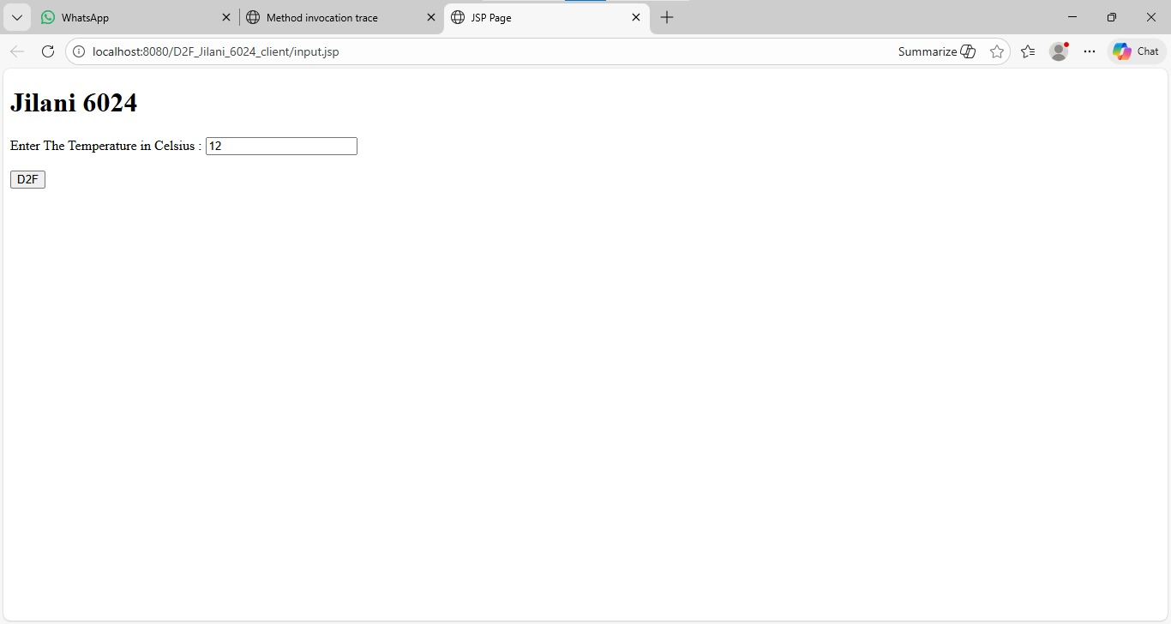
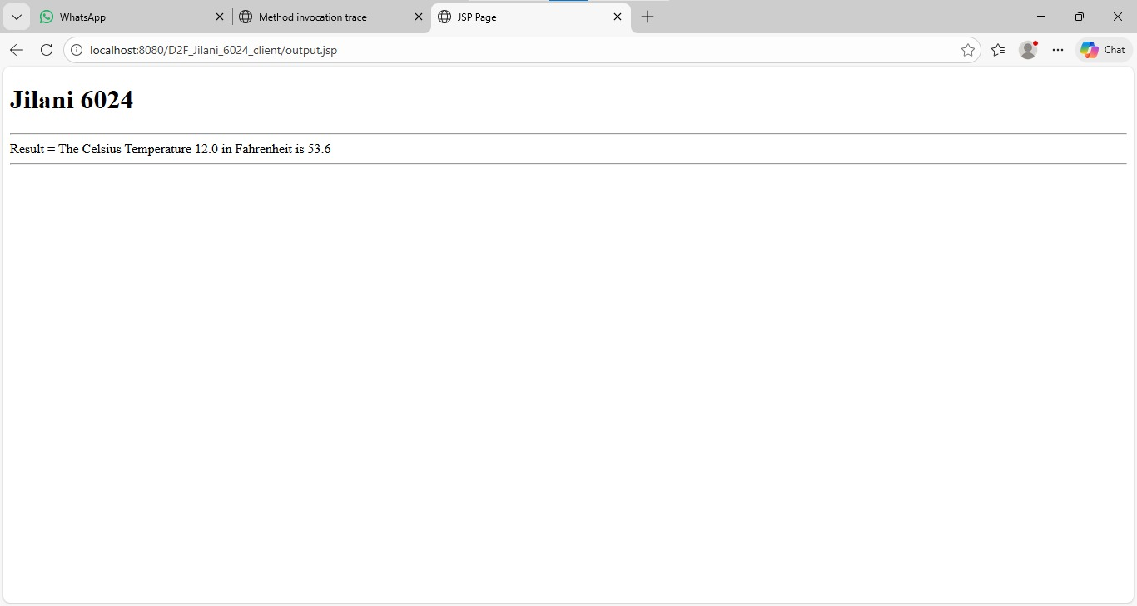

Python Client
Input:-

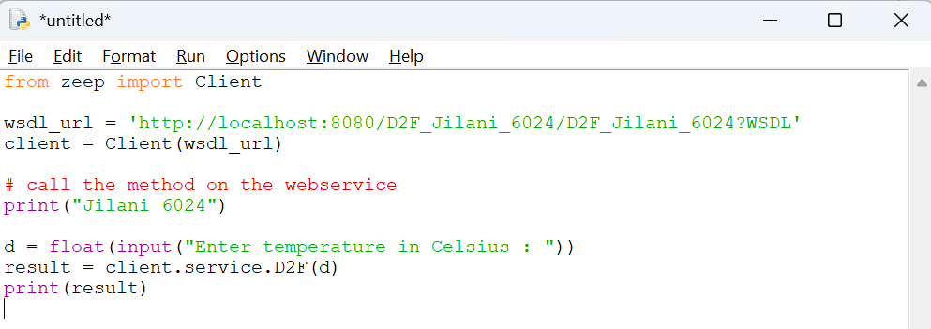
Output:
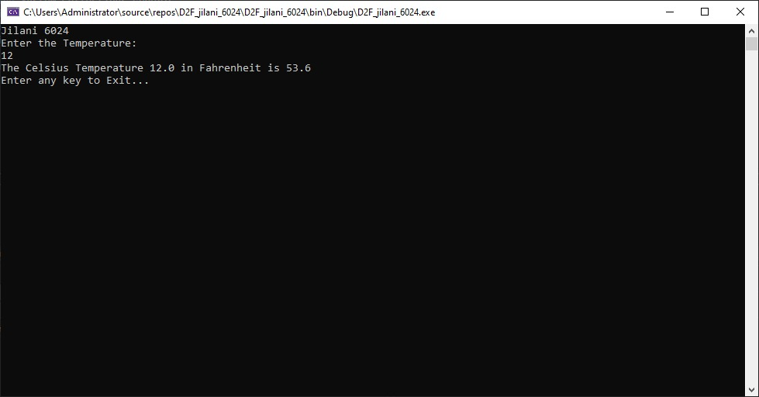

.Net Client:
